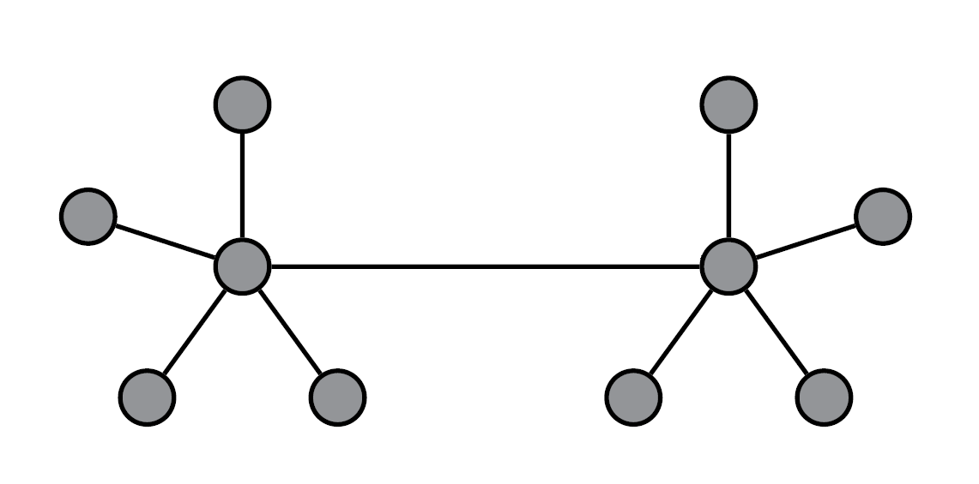

**Fog and Cloud FedSVM model with 10 workers**

GD: Number of iterations: 3000 / 3000

GD: final norm: 2.048095928327235

-------------------------------------

Runtime GD num_iters= 45.49141478538513

final cost with GD 43.148475259929675

final acc on Cloud FedSVM_GD: 0.9391698113207547

acc_final_GD= accuracy(W_GD[:, 4].reshape(d, 1) + W_GD[:, 5].reshape(d, 1) / 2, X_test, Y_test)

SGD: Number of iterations: 3000 / 3000

SGD: final norm: 10.65235394695729

-------------------------------------

Runtime SGD num_iters= 35.59947061538696

final cost with SGD 78.52559686192956

final acc on Cloud FedSVM_SGD: 0.9388679245283019

acc_final_SGD = accuracy(W_SGD[:, 4].reshape(d, 1) + W_SGD[:, 5].reshape(d, 1) / 2, X_test, Y_test)



    
    
    
    
    
    
    